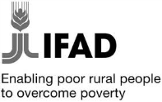
Government of Nepal
Ministry of Agricultural Development
High Value Agriculture Project in Hill and Mountain Areas

HVAP Bulletin

Year 1, Volume 3 Quarterly e-newsletter, November 2013

Message from the Editorial Team

Dear valued readers,

We are pleased to present you the third issue of HVAP Bulletin, our quarterly e-newsletter. It brings you an update of recent happenings at the High Value Agriculture Project in Hill and Mountain Areas (HVAP) and in the arena of agriculture.

HVAP is being implemented by Ministry of Agricultural Development (MoAD) and is financed by International Fund for Agricultural Development (IFAD). The project aims at integrating the rural poor, especially women and marginal groups to the high value agriculture and NTFP/MAP value chains for improved income, employment opportunities and ability to respond to market demand and opportunities based on marketing agreements with private agribusinesses. The project covers nine districts of Mid-Western Development Region and one district of Far Western Development Region. SNV Netherlands Development Organisation and Agro Enterprise Centre are the implementing partners of the project.

The newsletter comprises the news and events happening at HVAP, important updates in the field of agriculture, articles on agriculture, sharing from partners and information on our communication and dissemination activities.

We believe you will enjoy the content. Please write to us at info@hvap.gov.np for any information regarding the project and we would request to forward the newsletter to interested readers in your network.

Happy reading!

The Editorial Team

Learning Routes in Nepal and the Global South: A Pilgrim for Knowledge  The second version of the first Learning Route in Nepal entitled Women Empowerment, New Businesses and Sustainable Natural Resource Management in Nepal was opened for implementation in Kathmandu on 13 September 2013.  Read more… | Success Story of Aamdada in Tanahu District  Seven years ago, Aamdada was degraded steep land densely covered with Lantana camara. After handing over the degraded land plots to the groups, the ultra-poor people started to cultivate stylo, molasses, napier, badame, Setario paspalam etc. Similarly, they started to grow fruit trees such as mango, pineapple, banana, litchi etc. on their shifting cultivations areas.  Read more…
Governance of Agricultural Cooperatives in Hill and Mountain Areas of Nepal: The Case of HVAP  The cooperative movement started in Nepal after the end of Rana regime and restoration of democracy during 1950s.  The paper highlights the governance situation of cooperatives in hill and mountain areas of Nepal, the working districts of HVAP.  Read more… | Cell of Change  Mobile technology has greatly aided farmers in India; Nepal should emulate such practices. The farmers in India can obtain information on market prices, weather conditions, agricultural policy news, and tips on farming cycles via short message service (SMS) from Reuters Market Light (RML).  Read more…
18 Must Read Books in Agriculture  Four times a year, Food Tank handpicks a selection of books (mostly newer editions, but several oldies). Food Tank's "must read" Fall 2013 selections for those who are passionate about a more sustainable food system! From practical tips on sustainable agriculture on a warming planet to insight on how to make jam, these reads will provide plenty of food for thought.  Read more… | Top 20 Agriculture Blogs  The listed blogs provide useful information and insightful commentary on agricultural issues and topics. Seametrics selected them based on their great content and recommendations from other bloggers.  Republished from www.seametrics.com.  Read more…
News and Events  MIS Exchange Visit to Uttarakhand  Interaction programme on Progress Review and Implementation  Training cum Workshop on Blissful Life Management Organised  Trainings Organised for Groups and Cooperatives  Project Investment and Contracts Facilitation  HVAP Wins the Innovation Marketplace Award  Implementation Support Mission  Press Meet Organised  PCCG and PSC Meetings Held  Regional Level Training on Value Chain Commodities  Secretary of Ministry of Agricultural Development Visits HVAP | Agriculture in the news  HVAP Publications and Notices  HVAP Radio Programme  Agriculture Cartoon
Learning Routes in Nepal and the Global South: A Pilgrim for Knowledge

Throughout history, the word “route” has been a synonym for adventure and discovery: in the case of the “Learning Route”, this adventure will yield new knowledge, successful and enlightening experiences, fresh ideas and innovative solutions. Supported by the International Fund for Agricultural Development (IFAD), the PROCASUR Learning Route Programme is designed with the aim of improving knowledge sharing in rural development. It provides practitioners, researchers and policymakers with concrete ideas and tools to adopt and adapt best practices in their own countries and organisations. Learning Routes are being organised in Asia and the Pacific, Africa and Latin America.

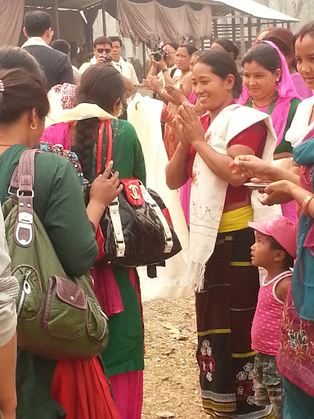
T he second version of the first Learning Route in Nepal was opened for implementation in Kathmandu on 13 September 2013. Entitled Women Empowerment, New Businesses and Sustainable Natural Resource Management in Nepal was a common effort of the IFAD and the PROCASUR Corporation - with the full support of the High Value Agriculture Project (HVAP), Leasehold Forestry and Livestock Programme (LFLP), Poverty Alleviation Fund (PAF) and West Upland Poverty Alleviation Project (WUPAP) – this field-based training programme focussed on the main theme of “women empowerment, new businesses and sustainable resources management in Nepal”.

Over thirty participants, many of them coming from Asian and African countries, took part in the action-packed journey that took them to Kavre, Chitwan and Kapilvastu districts to learn directly from the best practices and innovative solutions of local co-operatives, mostly managed by women.

“Learning Routes can be an effective learning mechanism for us all”, acknowledges Mr Rajendra Prasad Bhari, Project Manager of HVAP. “At community level, farmers will learn about the methodological approach to expose and document knowledge which could be helpful for them to improve their livelihoods. At policy-making level, it should help develop and institutionalise a system that enhances dissemination of best practices and innovation for their scale-up at regional or national level,” he points out.

Originally developed in South America by the Regional Corporation PROCASUR in the late 1990s, the Learning Route methodology emphasises learning from the field and provides novel ways for knowledge development and exchange amongst different stakeholders. Participants on the Learning Route are taken to visit local initiatives that embody best practices; in this framework, local actors become trainers, sharing their knowledge and innovations with their guests during field visits.

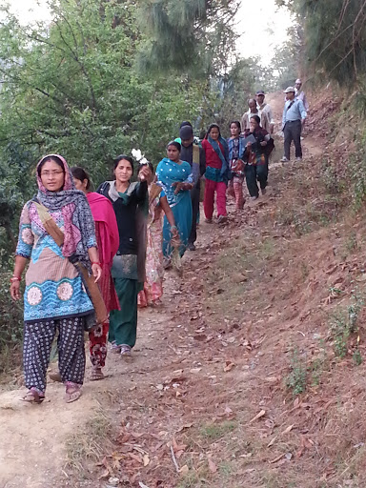
The Learning Route is a way to promote rural development knowledge market that positively includes learning among project staff, grassroots organisations and local actors. This will continue after the end of the journey itself, allowing development projects the methods and tools to adapt and expand innovations and best solutions for the rural poor communities. While travelling the route, in fact, participants work with facilitators to identify the specific lessons that are relevant to their individual contexts and organisations. The end goal is for the local participants to become more effective and strategic in their own context; in this sense, the Learning Route encourages each participant to come up with a concrete innovation plan for actions. This approach allows innovations to travel from place to place.

Mr Bashu Aryal, IFAD Country Programme Officer in Nepal, stresses that “sharing and learning from successful experiences is the ultimate goal of all learning organisations. I do hope that through “Learning Routes”, participants will be able to view things from very different eyes and perspectives so that they come back with proven solutions to address poverty in Nepal while improving efficiency and sustainability of all our projects”.

For more information about the Learning Routes in Asia and in Nepal please visit: www.asia.procasur.org and follow www.facebook.com/procasur.asia

Success Story of Aamdada in Tanahu District

In Tanahu district, there are 455 leasehold forestry groups covering a forest area of 1,964.35 hectares which have been contributing to 3,473 households of mostly Gurung community for their livelihoods. Out of 455 groups, 6 groups in Aamdanda have been successful in improving their livelihoods as well as forest condition through leasehold forestry and livestock programme.

We can reach Aamdada leasehold forest walking on foot for around 45 minutes from Muglin Narayangadh Road towards Deoghat.

Seven years ago, Aamdada was degraded steep land densely covered with Lantana camara. Maize, millet and lentils were later cultivated there through traditional method. School children kept vigil on the cultivated areas by making small watching tower to save the crops from monkeys. The ultra-poor people of the area were suffering from daily hand to mouth problems and their children were prohibited from education. Considering the alarming situation of the area and the settlers, i.e., Gurung people, District Forest Officer, Tanahu took an initiation to organise them for leasehold forests in 2006 (FY 2063/2064) and implement the activities for their livelihoods after the formation of six leasehold forest groups.

After handing over the degraded land plots to the groups, the ultra-poor people started to cultivate stylo, molasses, napier, badame, Setario paspalam etc. Similarly, they started to grow fruit trees such as mango, pineapple, banana, litchi etc. on their shifting cultivations areas.

In 2008 (FY 065/066) District Forest Officer, Tanahu announced one of leasehold forestry groups named Piredharee Leasehold Forest as model leasehold forest to carry out additional activities for uplifting the livelihoods of the poor people. Other five leasehold forestry groups attempted to mimic the activities being conducted at Piredharee Leasehold Forest with cultivation of Amriso in their leasehold forests proved to the great opportunity for them to uplift their livelihoods earning NRs 200,000 income. Currently approx 15 % of the leasehold forests have occupied with fodder and grasses and the rest of the areas were covered with Amriso. The surrounding people have also started to cultivate it for income.
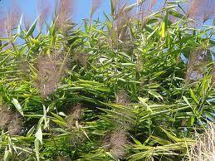
Nowadays, members of leasehold forestry groups are rearing 35-40 goats with sufficient grass and fodder. They are earning through the sale of Amriso brooms, seeds of grasses and the other NTFPs in one hand, and on the other hand, their children have got rid of working as watcher and they are now busy in studies. Aamdada has become destination for tourists and other forestry groups nationwide. The leasehold group received National Environment Conservation Award and NRs 25,000 provided by Ministry of Science, Technology and Environment, Nepal. The ultra-poor people are currently able to meet their hand to mouth problems. They have been expected to uplift their livelihoods better in days to come through the sale of Amriso broom and varieties of racks. They are no doubt living happy life within the short interval of seven years.

Exactly similar conditions were found in Baidi Village Development Committee ward No. 1, Jhakyochyo Leasehold Forest, where pineapple is the major source of income. This group has converted eroded steep land into dense forest in the upper canopy and varieties of grasses (stylo, molasses, napier etc.) inside the tree species.

Governance of Agricultural Cooperatives in Hill and Mountain Areas of Nepal: The case of HVAP

Padam Bhandari

Introduction
The cooperative movement started in Nepal after the end of Rana regime and restoration of democracy during 1950s. And during the 1990s the farmers’ agricultural producer groups and cooperative organisations appeared on the market. They are voluntary but profit oriented organisations whose main purpose is to jointly sell their members’ produce. The producer’s groups established cooperatives to market their produce in the legal forms.

This paper highlights the governance situation of cooperatives in hill and mountain areas of Nepal, the working districts of High Value Agriculture Project (HVAP). HVAP is a joint endeavor of the Government of Nepal/Ministry of Agricultural Development (MoAD) and the International Fund for Agricultural Development (IFAD). The project duration is of six years, from February 2011 to September 2017. MoAD is the executing agency of the project with the SNV Netherlands Development Organisation (SNV) Nepal and the Agro Enterprise Centre (AEC) as implementing partners. Local NGOs contracted by the project are particularly responsible for social mobilisation and the implementation of activities at the grassroots level.

Instituting good governance at farmers’ cooperative organisations would help farmers increase the amount of goods offered in the market, save on transaction costs, and overtake a portion of profits conventionally gained by middlemen. It could be expected as one important response to such problems. The High Value Agriculture Project had undertaken an assessment on the governance situation of the cooperatives in a participatory way to ensure ‘ownership’ of the procedure and the outcomes of it and to assess strong and weak aspects of cooperatives as a starting point to identify areas of improvement. The data of the governance situation discussed here was collected from 17 groups and cooperatives of Surkhet, Dailekh and Jumla districts of Nepal.

The governance assessment consists of a toolkit comprising six indicators with five sub-indicators using four parameters. Based on discussion among the cooperative members and staff, they were able to rate the performance of the cooperatives in each item and category. Depending upon the discussions and the answer of the cooperatives, each item and category under review is given a score. The total points scored by the cooperatives determine the overall impression on the governance condition of the cooperatives. Where the assessment score was low or moderately low, the capacity strengthening plan was developed on the low scored indicators. The score of the individual component then transferred into a table, a tabular representation of the organisation’s institutional capacity. From the table it was easy to identify where the strengths and weaknesses of the organisation lie.

The six indicator sections comprised 120 questions in total. Two types of questions were discussed: the first was related to facts such as numbers or descriptions of processes, the second to the subjective evaluation of these facts. Although governance checks is a subjective judgement and is the expressions of the individual's own attitudes like their thoughts, feelings, personal opinions, it can be categorised as the following:

Total Score | Total Status | Indicator-wise Score | Indicator-wise Status
30 | Poor | 5 | Poor
31 - 60 | Moderate | 6 – 10 | Moderate
61 – 90 | Good | 11- 15 | Good
91 – 120 | Very good | 16 – 20 | Very good

Results
In total 17 producer groups and cooperatives were subjected to the assessment, and the assessment score was as the following:

SN | Name of Cooperatives | Address | Scores achieved
 |  |  | Internal Organisation (20) | Programme (20) | Resource mobilisation (20) | Participation and Representation (20) | Transparency and accountability (20) | Production and marketing (20) | Total (120)
 | Kedar Bhairab Krishi Sahakari Sanstha | Jumla | 14 | 12 | 10.5 | 9 | 10 | 8 | 63.5
 | Yuba Krishi Sahakari Sanstha | Jumla | 14 | 13 | 13.5 | 12 | 11.5 | 10 | 74
 | Jolly Mugra Pashupalan Samuha | Jumla | 13 | 12 | 13 | 10 | 11 | 10 | 69
 | Kalika Mabai Krishi Samuha | Jumla | 14 | 13 | 11 | 8 | 14 | 5 | 65
 | Falful tatha Tarkari Krishak Samuha | Jumla | 12 | 11 | 12 | 9 | 9 | 10 | 63
 | Kalika Tarkari tatha Syau Utpadan Samuha | Jumla | 12 | 11 | 7 | 10 | 9 | 8 | 57
 | Mahila Falful tatha Tarkari Utpadan Samuha | Jumla | 12 | 12 | 13 | 8 | 11 | 11 | 67
 | Rara Syau byabasthapan Krishak Samuha | Jumla | 15 | 10 | 8 | 5 | 7 | 8 | 53
 | Lalikanda Multiple Sahakari Sanstha | Dailekh | 14 | 8 | 11 | 10 | 9 | 7 | 59
 | Him Shikhar Multiple Sahakari Sanstha | Dailekh | 13 | 11 | 9 | 7 | 8 | 5 | 53
 | Gotpada Krishak Multiple Sahakari Sanstha | Dailekh | 13 | 10 | 11 | 6 | 6 | 7 | 53
 | Deutisthan Mahila Multiple Sahakari Sanstha | Dailekh | 9 | 10 | 8 | 11 | 8 | 5 | 51
 | Kankretada Multiple Sahakari Sanstha | Dailekh | 13 | 10 | 9 | 7 | 8 | 5 | 52
 | Shree Jagriti Agri Cooperative | Surkhet | 10.5 | 10.5 | 8 | 6.5 | 7 | 6 | 48.5
 | Shree Jagganath Cooperative | Surkhet | 16 | 14.5 | 13 | 12 | 15.5 | 12.5 | 83.5
 | Veri Agri & Livestock Cooperative | Surkhet | 11 | 14.5 | 15.5 | 13 | 11.5 | 11 | 76.5
 | Malchari Multipurpose Cooperative | Surkhet | 17 | 14 | 9.5 | 12 | 14 | 6 | 72.5
 | Average |  | 13.09 | 11.56 | 10.71 | 9.15 | 9.97 | 7.91 | 62.38

By the time when the assessment was carried out, none of the groups and cooperatives were poor, eight groups were moderate, nine were good and none of the groups and cooperatives was very good in their overall status. Regarding the outcome of the indicator-wise status, in terms of internal organisation, only one cooperative was moderate, fourteen were good and two were of very good status. In terms of programme, only one cooperative was moderate and sixteen were good. In terms of resource mobilisation, seven cooperatives were moderate, nine were good and only one was very good. Regarding participation and representation, one was poor, eleven were moderate and five were good. Regarding transparency and accountability, ten were moderate, six were good and one was very good. Regarding production and marketing, four cooperatives were poor, ten were moderate and three were good.

Regarding the factors which resulted in poor and moderate status, the leaders most frequently pointed to the problem of knowledge, attitude and motivation of the people. It had to do with commitment, trustworthiness and confidence of the leader and other members. Some groups stated having problems in finding market. Considering the main output produced by the members, majority of them were dealing with different kinds of vegetables and fruits. The highest percent of weakness was seen on their production and marketing parts.

Conclusions
Agricultural producer groups and cooperatives are examples of new forms of cooperative arrangements in agricultural markets. The functions they are trying as business enterprises but limited within their local communities and are similar to traditional rural saving and credit cooperatives. The result of the assessment shows that the persons involved in cooperatives are at the beginner-basic knowledge level of business and have limited experience on entrepreneurial competencies. The members are applying general knowledge in common situation but has limited practical experience in applying the competency in a business work environment in the complex situations.

Increasing attention need to be given to entrepreneurship as a component of economic growth. Entrepreneurship plays a vital role in the economic development of the community and it can be as well linked to economic growth and ultimately to the overall prosperity of the district. Therefore, the training and coaching on entrepreneurial competency development to group and cooperative members can help them to grow and develop the cooperatives. The functioning and sustainability of the cooperatives depends on this and the project need to focus in these areas.

Padam Bhandari is an Institutional Development and Organisational Strengthening Advisor in Netherlands Development Organisation/High Value Agriculture Project in Hill and Mountain Areas, Nepal. He can be reached at pbhandari@snvworld.org or phone number: (977) 9849-818800.

Cell of change
Mobile technology has greatly aided farmers in India; Nepal should emulate such practices

Sanjib Kumar Chaudhary (Republished from The Kathmandu Post)

The hills of Almora in Uttarakhand of neighbouring India resemble the landscape in Nepal. The culture and way of life of the people are similar too. However, farmers there are a little more fortunate than Nepali farmers. They can obtain information on market prices, weather conditions, agricultural policy news, and tips on farming cycles via short message service (SMS) from Reuters Market Light (RML). The RML service is delivered in the form of a simple SMS that fits into the daily workflow of the farmer in his/her preferred language. Information can be obtained on 450 crop varieties in eight different languages.

Mobile power
A woman hidden behind a veil narrated to me her experience with mobile technology. She had laid out the whole lot of crop to be dried out in the sun. It was a sunny day and there was no sign of rain in the horizon. Then she received an SMS from RML. Being illiterate, she ran to her daughter who read it out. The SMS predicted rain.

All at once, she collected her crop and stored it in a safe place. It rained just after that but her crop was safe. A lean farmer standing next to her shared a similar experience. He was ready to spray pesticide on his standing crop of vegetables. But he changed his mind after receiving an SMS notifying him of a light shower. It saved both time and money.

Such is the power of information. And it is a blessing when it comes to a mobile set worth a few thousand rupees and in your preferred language. In Uttarakhand, the RML services are free of charge, sponsored by the Department of Telecommunication and the German development agency, GIZ. In other parts of India, RML services can be availed of through a paid subscription. This service is being used by over 1.2 million farmers in 50,000 villages across 17 states of India. Even the information can be personalised based on the type of crop, region of the crop, region of the country and local language. This enables farmers to make informed decisions, reduce waste and maximise their profits.

Farmers are well informed about the prices of their produce in two nearby markets. It helps them sell their products at a fair price to buyers. The service also has a provision of flashing the name and mobile number of a farmer or a trader who wants to sell or buy the commodities. The seller and buyer can then negotiate with each other for an agreeable price.

Likewise, RML flashes the name and contact number of successful farmers periodically. The farmers end up receiving thousands of calls from fellow farmers asking them about their success mantra.

The farmers can also enquire about diseases and pests affecting their crops with experts and specialists through a toll-free number provided by RML. They simply need to dial the number and record their problems with the call centre employees. The problems are then discussed with experts and the caller gets a reply-call with prescribed solutions.

With the ever-growing use of mobile phones, farmers in Nepal are also discovering ways to make their life easier. Now they can enquire about the price of their produce at major markets and negotiate prices with middlemen, avoid unnecessary travel to fetch agricultural inputs (especially if it is not available in the market) and seal deals with buyers. Farmers in Surkhet and Dailekh in the Mid-West development region can find out the price of vegetables and fruits through an SMS service provided by the Agro Enterprise Centre. Likewise, by calling a toll-free number, they can find out the prices of vegetables and fruits through voicemail. This service was piloted by Practical Action.

Mobile innovations
While we are being hit hard by loadshedding, farmers in India have found a unique method to deal with power cuts. With the help of a device designed by Vijay Bhaskar Reddy Dinnepu, founder of Vinfinet Technologies, they can direct their irrigation pump motors to switch on and off whenever they choose.

Through the device, the motor can also call back the farmer if there is voltage fluctuation or a power cut. The device connects to farmers’ mobiles through an interactive voice response system (IVRS).

With the provision of krishi meter (electrometers measuring subsidised electricity for agriculture), Nepali farmers can now irrigate their crops even during the dry season at cheaper prices. A device similar to that of Vinfinet Technologies could help them cope with regular power cuts and they can avoid staying on their fields for the whole day and night—in the cold and heat—waiting for power to resume.

The brains that developed the popular Android application ‘Taxi Meter’ which calculates the price of the distance travelled in a taxi and prevents travellers from being fleeced by taxi drivers must not leave behind farmers and agriculture in the ‘mobile revolution’.

Ever growing mobile users
Cellphones, which are a necessity these days, is ubiquitous even in the remotest corners of the country. People living below the poverty line, above the line and the ultra-rich, all have access to mobiles and the telecom network. What aid workers could not do in decades has been accomplished in years by mobile operators. While the thought of building toilets in every household seems to be a dream, Nepalis from all walks of life hold mobiles in their hands. The private telecom service provider, Ncell, boasts of having reached the mark of 10 million subscribers while state-owned Nepal Telecom has similar claims (including Namaste, CDMA and 3G subscribers).

Like RML in India, across the developing world, mobile services in agriculture have focussed on sharing and obtaining information. The programmes developed so far provide farmers access to research and best practices, weather information and market prices via SMS, IVR or call centres. With the rise in population and intense competition in agriculture, it is of vital importance for farmers to increase their production and raise incomes. This is possible only if they have access to right information at the right time through mobile technology.

Recently, in an Information Communication Technology workshop held in Rajbiraj, one of the presenters asked the participants about the best way to reach people who do not have access to the internet. Three hands quickly rose in unison. The answer was the mobile phone in their hands. With millions of farmers with mobiles handy, what we need now is the right technology, like RML. It could be a ‘game changer’ for Nepali agriculture.

Read the original article by clicking the link http://www.ekantipur.com/2013/11/10/related-article/cell-of-change/380562.html

*Image courtesy: (c) The Kathmandu Post

18 Must Read Books in Agriculture

Four times a year, Food Tank handpicks a selection of books (mostly newer editions, but several oldies).

Below are Food Tank's "must read" Fall 2013 selections for those who are passionate about a more sustainable food system! From practical tips on sustainable agriculture on a warming planet to insight on how to make jam, these reads will provide plenty of food for thought.

These 18 books are listed in alphabetical order:
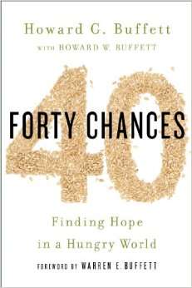
1) 40 Chances: Finding Hope in a Hungry World by Howard G Buffett with Howard W. Buffett and Forward by Warren E. Buffett

Howard G. Buffett, son of business tycoon, Warren Buffett, primarily identifies as a farmer. In 2006, given the opportunity to head his own philanthropic foundation, Howard G. Buffett embarked on a battle to fight food scarcity in the U.S., along with worldwide hunger. His book contains 40 stories from around the globe highlighting his endeavors to help those who lack food security.

2) 66 Square Feet: A Delicious Life by Marie Viljoen

A 66 square foot terrace in Brooklyn may not seem like a lot, but Marie Viljoen has drawn enough inspiration from her tiny rooftop garden to create a popular blog and compose a heartfelt book about it. Complete with astounding garden photography and delicious recipes, this book is sure to inspire anyone interested in seasonal eating and growing their own food.

3) Blessing the Hands that Feed Us: What Eating Closer to Home Can Teach Us About Food, Community, and Our Place on Earth by Vicki Robin

Vicki Robin chronicles her month-long endeavor to eat food solely from within ten miles of her Whidbey Island, Washington home. Reflecting upon her experiment of living as a locavore, the book features lessons on food and farming–interspersed with recipes and tips on how to lead a more sustainable life.

4) Cows Save the Planet: And Other Improbable Ways of Restoring Soil to Heal the Earth by Judith Schwartz with Forward by Gretel Ehrlich

Cows Save the Planet takes a “soil’s-eye view” of the problems currently facing the environment. Using soil as her springboard, Schwartz argues that for all the dire issues facing the planet, there is still hope for a bright future. This book is sure to uplift even those most despondent over global warming and the diminishing health of the planet.

5) Eat Drink Vote: An Illustrated Guide to Food Politics by Marion Nestle

Eat Drink Vote presents over 250 cartoons illustrating the complex connections between politics and food choice. Nestle collaborates with The Cartoonist Group to use humorous illustrations to simply explain the complicated intricacies of the food system.

6) First Food: A Taste of India’s Biodiversity by Sunita Narain and Vibha Varshney

The Centre for Science and the Environment’s Sunita Narain and Vibha Varshney come together to present a delicious look at India’s indigenous food. Food First is a cookbook featuring 100 recipes that showcase the immense biodiversity found throughout India.

7) Food DIY: How to Make Your Own Everything: Sausages to Smoked Salmon, Sourdough to Sloe Gin, Bacon to Buns by Tim Hayward

For anyone who has ever wondered about how to make his or her own bacon, Tim Hayward shows the way. Simple instructions paired with stunning photographs and illustrations make this an indispensable do-it-yourself guide for those with an interest in learning to make their own food.

8) Food Policy in the United States: An Introduction by Parke Wilde

Food Policy in the United States is a textbook for anyone interested in increasing his or her knowledge within the complex field of U.S. food policy. Agricultural economist Parke Wilde discusses the essential topics from international agricultural trade to food labeling.

9) From the Ground Up: A Food Grower's Education in Life, Love, and the Movement That's Changing the Nation by Jeanne Nolan with Forward by Alice Waters

Jeanne Nolan’s book presents her astounding memoir paired with a practical guide to organic farming. From the Ground Up demonstrates the benefits of sustainable agriculture for people, communities and the planet. Anyone interested in the food movement or just keen on growing their own food will delight in Nolan’s exhilarating adventure creating edible gardens across Chicago.

10) Gaining Ground: A Story of Farmers’ Markets, Local Food and Saving the Family Farm by Forest Pritchard with Forward by Joel Salatin

Forest Pritchard’s memoir about saving his family farm highlights the real cost of industrial farming. The tale brings the reader along a hilariously moving path toward the future of family farming, illustrating the importance of sustainable agriculture along the way.

11) Grand Forks: A History of American Dining in 128 Reviews by Marilyn Hagerty with Forward by Anthony Bourdain

North Dakota food critic, Marilyn Hagerty, releases her book on American Dining featuring 128 past reviews from restaurants such as The Big Sioux (a truck stop) and Grand Fork’s first Taco Bell. Hagerty’s book brings topics such as restaurant review elitism and the ever-shifting landscape of the American diet to light.

12) Growing Food in a Hotter, Drier Land: Lessons from Desert Farmers on Adapting to Climate Uncertainty by Gary Paul Nabhan with Forward by Bill McKibben

Traveling across desert lands from North America to the Arabian Peninsula, Gary Paul Nabhan’s guidebook provides expert advice on farming techniques adapted to arid regions. With climate change a pressing reality, this is a must-read for anyone interested in learning new practices to keep their farms, gardens, orchards, and backyards thriving far into the future.

13) Soil and Sacrament: A Spiritual Memoir of Food and Faith by Fred Bahnson

Traveling as an immersion journalist and religious pilgrim, Fred Bahnson examines the links between food and faith. Over the course of the year, Bahnson visits four gardens –one for each season– run by different faiths and reflects upon how people from across the religious spectrum are reconnecting with their food.
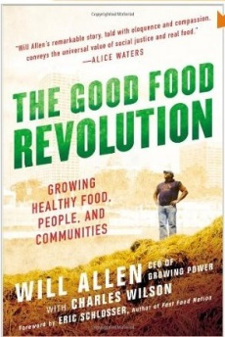
14) The Good Food Revolution: Growing Healthy Food, People, and Communities by Will Allen with Charles Wilson and Forward by Eric Schlosser

Former professional basketball player Will Allen has inspired countless people to reclaim their food system. After establishing his organization, Growing Power, along with its two acre urban farm, Milwaukee's food system has undergone a number of positive changes. His personal journey has also encouraged a number of similar farming programs across the country.

15) The Modern Peasant: Adventures in City Food by Jojo Tulloh
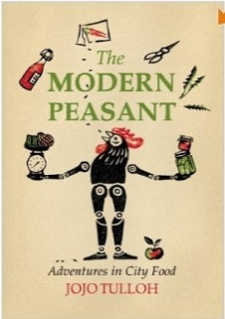
London, like a number of cities, is brimming with small-scale food producers. Jojo Tulloh’s story takes an in-depth look at the shifting landscape of food production in London and offers a number of practical tips and advice on how to become a part of the food movement– one batch of chutney at a time.

16) The No Nonsense Guide to World Food by Wayne Roberts

The updated version of The No Nonsense Guide takes a stark look at the challenges facing the global food system, namely the vast influence of agricultural corporations. Roberts goes on to examine new sustainable models of food production from around the world in hope of building a better food system.

17) Three Squares: The Invention of the American Meal by Abigail Carroll

Three Squares embarks on a historical journey chronicling American eating habits from colonial times through today. Viljoen unpacks the story of how Americans have come to adopt the standard three-meal-a-day routine and what to expect for the future of mealtimes.

18) What has Nature Ever Done for Us? How Money Really Grows on Trees by Tony Juniper with Forward by HRH The Prince of Wales

Nature provides humans with a wealth of seemingly “free” resources and services, from water to carbon absorption. By measuring the economic value of "natural services", Juniper argues that people must stop destroying nature. Told through a number of different stories, this book sees danger and hope for the future of the natural world.

Please note that several of these books are forthcoming and based on review copies, but so they'll be available soon!

Enjoy this list and share it with your friends and colleagues!

Compiled by:
Danielle Nierenberg
Co-Founder, Food Tank
foodtank.org
Email: danielle@foodtank.org
Phone: 202-590-1037

Top 20 Agriculture Blogs

(Republished from www.seametrics.com)

The following blogs provide useful information and insightful commentary on agricultural issues and topics. We selected them based on their great content and recommendations from other bloggers.

Small Farm Central Blog
Small Farm Central has a great weekly blog that includes a number of helpful hints for those that run smaller farms – especially about marketing and e-commerce.

Soil Doctor’s Blog
Agricultural consultant Brent Rouppet, Ph.D., blogs with a particular interest in soil science, agricultural, and scientific news.

Agricultural Entrepreneurship
Great information for Agriculture entrepreneurs about marketing, economics and news in the agriculture industry.

Machinery Chatter
Jim Patrico, Progressive Farmer Senior Editor, uses this blog about farming machinery to keep you abreast of new products, recalls, and more.

AgWired
AgWired is a very informative site/blog which focuses on what’s new in the world of agribusiness and agriculture marketing.

47 Japanese Farms
Two Americans living in Japan document their experience working on farms throughout Japan with the goal of working in all 47 Japanese states.

Agricultural Biodiversity
Separated by half a world but united by their passion for agricultural biodiversity and the internet, Luigi Guarino and Jeremy Cherfas created this blog to collect and discuss all things related to the notion of agricultural biodiversity.

Production Blog
Dan Davidson, DTN Contributing Agronomist, blogs about agronomy and crop production for growers and dispenses timely advice on production practices and decisions.

Alex Tiller’s Blog on Agriculture and Farming
Alex Tiller is a member of the American Society of Farm Managers and Rural Appraisers and also an agribusiness author/blogger. His excellent blog covers commercial farming, family farms, organic food production, sustainable agriculture, the local food movement, alternative renewable energy, hydroponics, agribusiness, farm entrepreneurship, farm economics and farm policy.

Farm Policy
Farmpolicy.com is a comprehensive site that closely follows federal-level farming policies and provides summaries that are helpful for non-lawyers.

Farmgateblog.com
Farmgateblog is an excellent place to go to find integrated information across a variety of disciplines, including crop and animal sciences, ag economics, ag engineering and agricultural policy.

Big Picture Agriculture
This blog from Kay McDonald, an independent agricultural researcher, aims to be your one-stop agricultural news source with continually updated news about agriculture, sustainability, energy, macroeconomics and weather.

RealAgriculture
RealAgriculture is a solid agriculture blog/news feed focused on “getting you the opinions on the issues so that you not only get the news but the insight into what the news means to your business.”

Organic Farming Blog
This blog was created for people with a passion for farming the organic way and for those wanting to learn.

National Sustainable Agriculture Coalition Blog
This blog from the National Sustainable Agriculture Coalition of Sustainable provides agriculture news about advocacy and policies relating to farm, food, and environmental issues, appropriations, and implementation.

The Social Silo
This interesting blog seeks to foster communication between farmers and nonfarmers, to share different perspectives, “to make us all think and grow a little”.

Think Forward Blog
This blog is written by the staff of the Institute for Agriculture and Trade Policy covering sustainability as it intersects with food, rural development, international trade, the environment and public health.

Ag on the Forefront
This blog from agricultural advocate Kelsey Pope is about keeping agriculture on the forefront and advocating for those that keep the livestock and grain industry healthy.

Advocates for Agriculture
Troy and Stacy Hadrick are fifth generation ranchers who travel the country to spread the positive story of agriculture and blog about the issues and news affecting farmers and ranchers.

Farmer Bloggers
Farmer Bloggers brings together several farmers to tell their stories and discuss topics in agriculture and farm life.

More Recommended Agriculture Blogs

Blogriculture
This blog, from the folks at Capital Press, cover all things agriculture on the west coast (California, Oregon, Washington, and Idaho).

The FBlog, from the American Farm Bureau Foundation for Agriculture, contains opinions and perspectives of some of the nation’s top producers. It is intended for the public as a whole to learn more about and discuss with producers today’s leading agricultural topics.

Ag Policy Blog
Chris Clayton, DTN Ag Policy Editor, blogs about a wide variety of agricultural policy related topics.

Above Capricorn
This is a great blog from an agricultural scientist (“Peter H”) with strong interests in cropping, land, water, wastewater, seed science and technology, and weed ecology.

If you would like to suggest an agriculture blog for this list, please email CharlesS@Seametrics.com.

Read the original article at http://www.seametrics.com/blog/top-agriculture-blogs/.

News and events

MIS Exchange Visit to Uttarakhand
HVAP organised an exchange visit to Uttarakhand of India from 21-27 October 2013 to gather a better understanding on Reuters Market Light (RML) services being used by the farmers in Aajeevika’s project area and to incorporate some of its good parts in current Market Information System (MIS) used by HVAP that is available through website, SMS and voice service.

The participants included Mr Govinda Shahi, President, Jumla DCCI; Mr Ganesh Kharel, Senior Vice-President, Surkhet DCCI; Ms Susma Rasaily, Agriculture Communication Officer, AICC, Ministry of Agricultural Development (MoAD); Mr Ghanashyam Chaudhary, Agriculture Officer, High Value Agriculture Project in Hill and Mountain Areas (HVAP); Mr Guru Prasad Adhikari, Agriculture Technician, HVAP; Mr Shreelal Chaudhary, Livestock Technician, HVAP; Mr Hari Madan Adhikari, Capacity Development Officer, Agro Enterprise Centre (AEC)/HVAP; and Mr Sanjib Chaudhary, Communication and Knowledge Management Advisor, SNV Netherlands Development Organisation/HVAP.
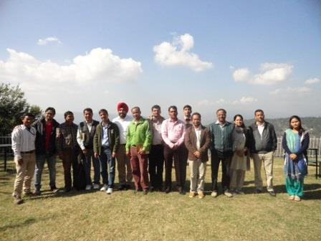
The team met with Ajeevika staff from Almora, Bageshwor and Dehradun, and RML staff from Chandigarh. Mr Kailash Bhatt introduced with his team and explained in detail about the programmes being implemented by Ajeevika. The team then visited Lamgada and interacted with the RML subscribers. The farmers, both men and women, shared their experiences and benefits of using RML services. Mr Shiv Tej Singh Sandhu presented on the RML services being provided to Uttarakhand farmers.
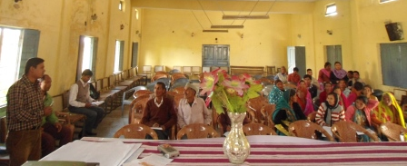
The team then visited the working areas of Ajeevika and observed the field activities including a Kroiler unit, feeding trough for cattle, plastic mulching, integrated poultry and dairy units. The team then visited shops operated by the cooperation federations and observed the milk analyzer, products being sold by them including Samruddhi ghada (plastic water pot and milk pot), cattle feed and spices.

Following day, the team visited the Almora market and observed the marketing system. The team also interacted with the farmers bringing their produce to the commission agent who sells the produce to the highest bidding trader. Mr Gurpreet Saini explained how the farmers are benefitting from the RML services that send SMS informing them of the market prices of their commodities.

The team then shared the experiences at HVAP with Ajeevika and RML colleagues. Mr Kailash Bhatta presented on the outcomes of Ajeevika. Sanjib Chaudhary explained in detail about the HVAP approach, way of working and innovations at HVAP. Likewise, Mr Shiv Tej Singh Sandhu presented in detail the RML services and its way of working.
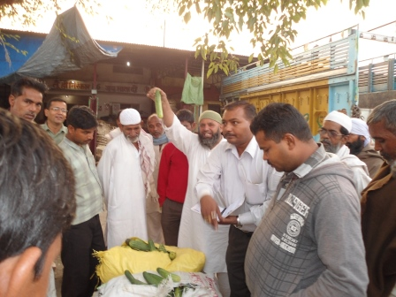
On the final day of the visit, the team visited the Haldwani Vegetable and Fruit Market which is the second largest market in Asia, after the Azadpur Sabji Mandi in Delhi. The team members observed the auction process and other processes of marketing where producers leave the produce with the commission agents who sell it to the producers offering the best price. The team also interacted with the government appointed recorder who records the volumes and selling prices of commodities. The team also discussed with the traders, commission agents and farmers. Mr Sambhu, a reporter with RML explained the process of recording the prices and sending it to RML.

Interaction Programme on Progress Review and Implementation Held in Birendranagar
A three days interaction programme on progress review and implementation was held on 26-28 September 2013 by HVAP amidst the presence of stakeholders including district line agencies, regional directorates, local NGOs, development partners and representatives from Ministry of Agricultural Development (MoAD).

Mr Jaya Mukunda Khanal, the Secretary, MoAD was the Chief Guest of the programme and Mr Shree Narayan Sharma, the Regional Director, Regional Agriculture Directorate (RAD) chaired the programme. Prior to attending the workshop, the Secretary and Regional Director visited and monitored the sub-projects being implemented by HVAP in Surkhet district.

The programme began with welcome speech by Mr Rajendra Bhari, Project Manager, HVAP. He also presented the project progress and status to the gathering. Following the presentation, Mr Krishna Thapa, Monitoring and Evaluation Expert and Mr Hikmat Rokaya, Database Management Expert from HVAP presented the Tablet-based Management Information System (MIS) being implemented by HVAP.

In the discussion session following the presentations, the participants enquired about the implementation modality and coordination of HVAP with district line agencies and other stakeholders. The Project Manager, HVAP elucidated the conditions and efforts made by HVAP for effective project implementation and coordination with stakeholders.

On the occasion, the Chief Guest Secretary, MoAD said, "HVAP's modality of partnership being led by Government of Nepal including private sector, I/NGO and communities is new for MoAD and we hope that it will ensure sustainability of the project activities even after the project completion."

The Chairperson of the Programme, RD of Mid-Western RAD said, "The MIS being implemented by HVAP is good and it needs to be replicated by the RAD, DADOs and other district line agencies."

In the second session, the Coordinators of partner NGOs from Achham, Jumla, Jajarkot, Dailekh, Kalikot, Salyan and Surkhet presented the progress and status of the sub-projects being implemented in their respective districts.

On the second day, Annual Work Plan and Budget (AWPB) was presented by Mr Sirish Pun, Planning, Monitoring and Evaluation Officer, HVAP. Following it thematic leaders presented the planning of each thematic group within HVAP. In the second session, a group work was organised including representatives from each District Chamber of Commerce and Industry (DCCI), NGO Coordinators and project staff to identify DCCI's role in promoting agriculture sector in each district. The discussion revolved around what was done by the DCCIs last year and what should be done by them in the coming year to promote agriculture.

The third day was devoted to the discussion with the partner local NGOs on finalising their action plans of current fiscal year. The management issues with the NGO management team were also discussed and the team came up with appropriate solutions. HVAP will incorporate the suggestions and inputs provided by the stakeholders during the interaction programme on progress review and implementation.

Training cum Workshop on Blissful Life Management Organised
A two days training cum workshop on "Blissful Life Management" was organised on 22-23 September by HVAP in association with Pathik Foundation in Birendranagar, Surkhet. HVAP staff and stakeholder representatives participated in the workshop that dealt with the holistic personality development including meditation, yoga, lectures and problem solving.

The Pathik Foundation is the "path of all saints". This is the path to true spiritual evolution leading to self-awakening for peace, prosperity and bliss. It includes most of the spiritual, mystical paths of east and west. It blends the teachings of all saints from Patanjali, Gorakhnath, Gautam Buddha to Osho.

The workshop was aimed at enabling the participants to achieve the possibility to get freedom from lust, greed, anger, attachment, jealousy, revenge, duality etc. and quench their thirst for peace, prosperity and bliss (Ananda).

The workshop began with a lecture on "Quest of life" by Acharya Shree Pathik. It was followed by sessions on "Right Paradigm (Free from Misery)" and "Stress/Personality Management". The day ended with Kundalini meditation.

The second day started with practising yoga asanas (yoga postures) and Sanjeevani meditation. It was followed by a lecture on "Art of Relationship and Communication" by Acharya Shree Pathik. A video on "Spiritual Reality" was screened and a session on "Laws of Success (Stages of Success)" followed it. The participants practised Yog Nidra (sleeping meditation) after lunch.

Dr Buddha Kumari Paudel facilitated the participants on queries about health and suggested for natural healing. Following it, sessions on "Work is Worship" and "The Art of Blissful Living" were conducted with Pragyasutra (songs based on moral lessons). The workshop concluded with a session on Kundalini meditation.

Trainings Organised for Groups and Cooperatives
A two days training on post-harvest management of off-season vegetables was organised on 12-13 September at Agriculture Research Station (ARS), Dailekh for farmers from HVAP grant receiving groups and cooperatives in Dailekh, Kalikot and Accham including staff and social mobilisers of the local NGOs.

The participating farmers and social mobilisers benefitted from the training gaining sufficient skills on general principles and practices of post-harvest of vegetables, techniques of identifying maturity indices and proper harvesting measures, importance of grading and packaging and other post-harvest handling practices, about different tools and packaging materials used in fresh vegetable handling, identifying and managing the major post-harvest diseases and disorders of fresh vegetables, and the basic principles of zero energy vegetable storage.

The training was facilitated by HVAP Technical Team including Ghanashyam Chaudhary, Nageswor Nayak and Guru Prasad Adhikari and Basant Chalise from ARS, Dailekh.

Similarly, organic ginger production training was organised on 29 September – 3 October at Lekhpharsa of Surkhet district. Likewise, a three days training on plastic house construction was organised on 30 October – 1 November at Matela of Jajarkot district.

Project Investment and Contracts Facilitation
HVAP has co-invested with the Organic Village (TOV) on a sub-project to set up a ginger processing unit in Surkhet. The TOV has formed a joint venture with Organic Mountain Flavour, Nepal (OMF) to establish the processing unit and serve the national and international market for organic ginger produced within the HVAP working areas. OMF is a joint venture between TOV (sister concern to The Organic Valley Pvt. Ltd. Kathmandu), Investors Home Pvt Ltd, Nepalgunj, Nepal (sister concern of Ratna Laxmi Group, Surkhet, Nepal) and Organic Mountain Flavour BV, Netherlands (Joint Venture between Handel en Exploititatie maatschappij Spapens BV and One to Watch BV).The total investment of TOV is NRs 11,946,614 (USD 119466.14) and HVAP investment in the sub project is NRs 8,409,775 (USD 84097.75). (1 USD = NRs 100)

TOV will produce high quality dried pieces, powder and candy to cater the Nepalese and European markets. TOV has an assured market with various buyers in Europe and Japan, catalysed through International Food Show BioFach Nurenberg, Germany and FOODEX Japan coupled with TOV outlets in Kathmandu.

The initial annual production capacity will be of 300 Metric Ton (MT) in 2013, followed by 450 MT and 600MT in 2014 and 2015 respectively. The project will produce the final products of 53 MT, 80 MT and 106 MT respectively in each of the three years.

OMF has entered into an MOU with farmers at Lekhpharsa and Pamka Village Development Committees (VDCs) in HVAP working areas for a buy-back agreement of ginger produced. Furthermore, OMF will potentially expand to work with farmer groups/cooperatives in Bame, Ghangharpiple, Lekhparsa, and Nigalchula VDCs within the HVAP Chhinchu–Jajarkot road corridor.

Likewise, HVAP co-invested with Seed Entrepreneurs' Association of Nepal (SEAN) Seed Service Centre Ltd., one of the leading vegetable seed processor and marketer in Nepal in a sub-project. SEAN would procure their seeds from Dailekh, Jumla and Surkhet with priority from the cooperatives/ FGs supported by HVAP. SEAN will procure 7 MT, 23MT and 3.5MT seeds from Dailekh, Surkhet and Jumla. To ensure the effectiveness of SEAN endeavours, HVAP will support SEAN in the areas of MOUs with producer organisation with due focus on target group and relationship building, facilitate and support for capacity development focusing on women and Dalits/Janajatis, marketing orientation on advertisement, publication and promotion and financial orientation on project financial requirement and advice on improvements, field visits and crop inspection and production in Surkhet/Dailekh through Production and Post-Harvest Support Fund.

The project also facilitated a contract between Dabur Nepal and timur collectors linking through local traders with clear benefit sharing mechanism and buy-back guarantee. With HVAP's coordination a buy-back guarantee of 14 MT of timur has been facilitated.

HVAP Wins the Innovation Marketplace Award
On 24 August 2013, during the IFAD Nepal Project Retreat and workshop, a Marketshare Fair was organised by Procasur where all the five IFAD Nepal projects (HVAP, WUPAP, LFLP, KUBK-ISFP and PAF) presented their evidence-based best practices and innovations, scaling up approaches and tools, multiple stakeholder approaches and new KM and communication strategies. Marketplace is a public space where people supplying and demanding knowledge meet to "negotiate" the exchange of ideas and innovative practices, as well as tools and approaches with high potential for up scaling.

HVAP’s innovations on multi-stakeholder platform, ‘respiration check’, tablet based data management system and value chain analysis bagged 26 votes in a total of 50 and became the winner of the Marketshare. The HVAP team received two full scholarships to attend the Learning Route in Thailand in October.

To read the full article, click the link.

Implementation Support Mission
IFAD Implementation Support Mission Team visited HVAP working areas and PMU in Surkhet from 16-19 August 2013. The mission team led by Mr Nigel Smith was composed of Mr Surya Bahadur Singh, Community Participatory Planning and Investment Specialist, Mr Bashu Aryal, IFAD Country Programme Officer and Mr Mahendra Poudel, Under Secretary from Ministry of Agricultural Development.

The mission assessed the progress in implementation of the agreed actions from the earlier review mission, provided management support to address emerging issues, reviewed potential risks to reduce potential impacts on project implementation from the ongoing political situation in Nepal and agreed on specific actions to be implemented before the Mid Term Review planned in January 2014.

The team visited HVAP working areas in Lekhpharsa, Kunathari and Shahare VDCs and provided feedback to the HVAP team on the programmes implemented.

Press Meet Organised
High Value Agriculture Project in Hill and Mountain Areas (HVAP) organised a press meet on 7 August 2013 at Regional Agriculture Directorate (RAD) in Birendranagar Surkhet. Journalists representing national dailies, local newspapers and FMs, representatives of District Agriculture Development Office (DADO), RAD, District Chamber of Commerce and Industries (DCCI) and HVAP staff were present at the meet.

Krishna Thapa, Monitoring and Evaluation Expert and Sirish Pun, Planning, Monitoring and Evaluation Officer presented the status, progress and future plans of the project. Following the presentation a discussion session was held where the journalists interacted on issues related to project implementation with the project staff and representatives from DADO, RAD and DCCI.
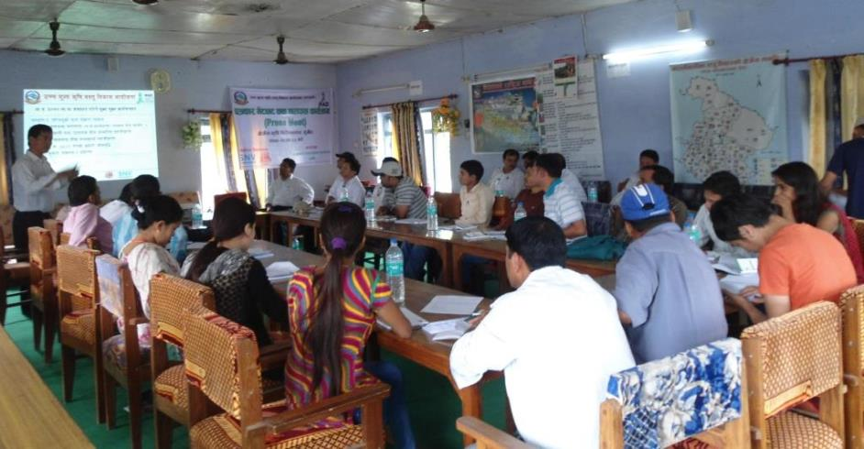
Thanking the journalists for the fruitful discussion Rajendra Bhari, Project Manager, HVAP said, "Media is the vehicle to disseminate our activities to a wider audience and we rely on local media to carry our message to them." He further emphasised on partnering with media for disseminating the news related to HVAP.

Click the link below to view the newspaper clippings on the press meet.

http://www.hvap.gov.np/gallerydetails.php?id=33

PCCG and PSC Meetings Held
High Value Agriculture Project in Hill and Mountain Areas (HVAP) organised the 6th Project Coordination and Consultative Group (PCCG) meeting in Surkhet on 10 July 2013. Likewise, HVAP organised the 7th Project Steering Committee (PSC) meeting in Kathmandu on 14 July 2013. The Secretary, MoAD chaired the meeting. The PSC endorsed the NGO Mobilisation Guidelines and HVAP Knowledge Management and Communication Strategy with inputs from the forum. The HVAP Annual Work Plan and Budget (AWPB), project progress and status were presented at both the meetings. Likewise, the 7th PCCG meeting was held on 30 October 2013 and the 8th PSC meeting was held on 7 November 2013.

Regional Level Training on Value Chain Commodities
A seven days’ regional level training on value chain commodities off-season vegetables, apple, vegetable seeds and goat for local NGOs and frontline extension workers was conducted by High Value Agriculture Project in Hill and Mountain Areas (HVAP) in Jumla. The training was organised at the Horticulture Research Station in Rajikot, Jumla from 14-20 June 2013. The training was successful in refreshing and updating the technical knowledge of the participants from Kalikot and Jumla districts including NGO staff, social mobilisers, Junior Technician/Junior Technical Assistants (JT/JTAs).

The training participants were instructed on the techniques of vegetable nursery raising, technological packaging of off-season vegetables (tomato and broad leaf mustard), identifying and managing major insect pests and diseases of vegetable crops, knowing different factors responsible for post-harvest loss in fresh vegetables, and knowing importance and technique of grading and packaging fresh vegetables.

Likewise in vegetable seeds value chain, the participants learnt general principles and practices of vegetable seed production, technical packaging of vegetable seed production (of radish, broad leaf mustard, carrot and coriander) and post-harvest handling of vegetable seeds, knowing about the different vegetable seed standards, sample taking of vegetable seeds, testing of seed vigour, identifying and managing the major insect pests and diseases of vegetable seeds, and inspecting the vegetable seed field and rouging out the off-type.

In goat value chain, the participants were instructed on identifying different breeds of goat, knowing about improved goat-shed and its management, identifying major fodder tree and grasses for goat. They also learnt about growing fodder trees and grasses and preparing balance diet, mineral blocks, and tatno, and identifying and managing the major parasites and diseases of goat.
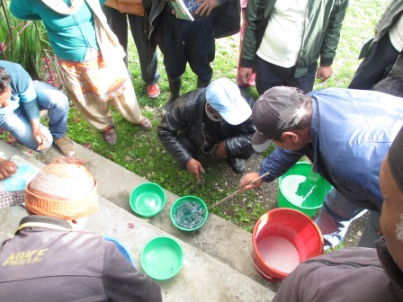
Similarly in apple value chain, the participants were taught on the basic technical information on apple varieties, rootstocks, growth stages and relevant orchard management activities. They were also oriented on pruning techniques, Bordeaux mixture and Bordeaux paste preparation, and organic manure preparation. Likewise, they also learnt the techniques of identifying maturity stage and correct method of harvesting apples and the importance of grading and packaging. They were also oriented on different tools, equipment and materials used in determining maturity indices, harvesting, grading and packaging of apples, and basic principles of cellar storage. After the training, they were also able to identify and manage the major diseases and insect pests of apple.

The training module was prepared in consultation with District Agricultural Development Office (DADO) and District Livestock Services Office (DLSO) Jumla and Kalikot. It is expected that after the training the field level staff, JT/JTAs and social mobilisers will be able to deliver the technical services related to various aspects of production and postharvest of the targeted commodities.

Similarly, a seven days’ regional level technical training on value chain commodities off-season vegetables, vegetable seeds, ginger, turmeric, timur and goat for partner NGO staff was conducted by High Value Agriculture Project in Hill and Mountain Areas (HVAP) in Dailekh. The training was organised at the District Livestock Services Office and Agriculture Research Centre, Dailekh from 14-20 June 2013. The training was successful in enhancing the common understanding of the participants on theoretical and practical aspects of production and post-harvest management of the six value chain commodities.

The participants were oriented on goat breed, their nutrition and management aspects including problems associated with the commercial goat rearing. Likewise, they learnt applying various technologies of production and packaging for off-season vegetables, ginger, turmeric and timur and delivering the acquired technologies to the farmers at field level.
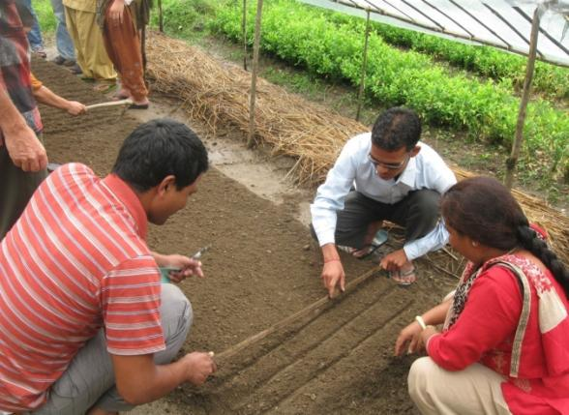
Similarly, the sessions on understanding the major diseases and pests of off-season vegetables, ginger, turmeric and timur and their management taught them on supporting technically to the farmers at field level. The sessions helped them on having clear understanding on the practices of post-harvest handling of off-season vegetables, ginger, turmeric, timur and vegetable seeds to minimise the cost of production. It also helped developing an understanding on principle and practices of vegetable seeds production and the prevailing laws and directives related to the seed quality standards.

Likewise, the participants learnt preparing mineral block and tatno related to goat value chain and preparing nursery raised beds with plastic covering for off-season vegetables. Similarly, they also learnt about facilitating rhizome (ginger, turmeric) treatment and vigour, purity and germination test of seed.

The training is expected to increase the effectiveness of partner NGO staff and the exposure to the best agriculture practices in the Agriculture Research Station and farmers’ field in Dailekh is expected to motivate the farmers to adopt those practices.

Secretary of Ministry of Agricultural Development Visits HVAP
Mr Jaya Mukunda Khanal, Secretary, Ministry of Agricultural Development, visited the Project Management Unit of HVAP in Surkhet on 12 June 2013.

Mr Hari Prasad Gurung, Senior Agriculture Officer, HVAP briefed him on the project accomplishments till date and current activities. In the meeting with the HVAP staff, honourable Secretary enquired about the problems and challenges faced by the project in terms of coordination and budgetary aspects.

Further, he also enquired about the coordination between the project and regional directorates, DADOs and DLSOs and suggested to coordinate well with the line agencies.
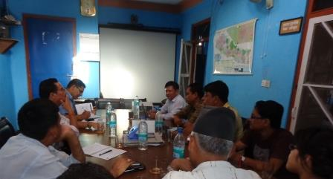
He also asked about the local NGOs and their capacity to implement the field activities. Mr Gurung provided a brief account of capacity building training and support provided to the NGOs and line agencies. He also clarified the roles and responsibilities and involvement of the line agencies in the project implementation.

Discussing the implementation challenges of the project, honourable Secretary encouraged the project staff to work towards meeting the goal of the project.

Agriculture in the News
Ayo A-du-wah (Republished from The Nepali Times)
Already #4 producer of ginger in the world, Nepal can lift farmers out of poverty with this cash crop

Tsering Dolker Gurung in SURKHET

At age 70, farmer Kabi Ram Thapa Magar did something he had never done before in his long life. He stopped growing maize and switched to ginger.

Thapa Magar was reluctant at first and full of doubt: what if the crop failed or he couldn’t get the right price? He would have neither food, nor money. But with neighbouring farmers in Lekhpharsa of Surkhet district, he took the plunge.

He hasn’t regretted the decision. He says: “I found that the value of a year’s production of ginger is equal to that of 10 year’s production of maize.”

The increase in demand for the spice cash crop has encouraged farmers here to triple the area under ginger cultivation. Farmers had been reluctant to switch to ginger because they didn’t have a cushion against a collapse in market prices.

“We didn’t have any other option than to sell our ginger at whatever price the middlemen gave us because if we didn’t it would just go to waste,” says Laxmi Kharel, another ginger farmer here.

With an increase in demand for ginger in the international market, Nepal’s total production grew three-fold to Rs 1.31 billion in the past year. Nepal is now the world’s fourth largest ginger producer after India, China, and Indonesia. More than 60 per cent of Nepali ginger is exported to India because there are no processing plants here.

“Our fresh ginger is exported to a processing country which exports it for a much higher value,” says Rajendra Bhari, project managaer of High Value Agriculture Project (HVAP). “If we establish ginger collection and processing centres within the country, export volume will increase and so will the value of our products.”

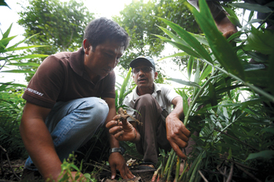

PIC: BIKRAM RAI
EXPERT HANDS: Farmer Kumar Prasai (right) shows Samir Newa (left) of Organic Mountain Flavour freshly harvested ginger in Lekhpharsa, Surkhet district,

Which is exactly what the government’s HVAP is trying to do with support from the Dutch group SNV in partnership with Organic Mountain Flavour, a private company that has been involved in organic ginger production for over three years.

Together the project aims to give 320 families direct access to markets for their ginger and repeat its success story with Jumla’s apples (see below).

“We have a committed and assured market through a strategic partnership with various buyers in Europe and Japan,” says Samir Newa, managing director of Organic Mountain Flavour which is also building a processing plant in Surkhet to manufacture high quality dried ginger powder and candy for the domestic market and export.

Farmer groups in village around Surkhet will supply Organic Mountain Flavour with a set amount of ginger at a fixed negotiated price and farmers can earn up to 15 per cent more if the ginger is certified to be organic. Newa hopes to be able to double this year’s 300 tons of processed ginger production by 2015.

Ginger is the main cash crop in the midhills of Nepal and the soil and climate of Surkhet Valley is primarily suited to it. Illam in eastern Nepal is the biggest ginger producing district. This spice crop is used to make a wide range of products including curry powder, jam, jelly, candy, and sauce and also has medicinal uses. Ayurvedic facilities in India and Nepal are also increasingly using ginger in their products.

Surkhet’s ginger farmers like Kharel are happy they are not vulnerable anymore to the vagaries of the market. She says: “It is great relief that we don’t have to carry our ginger to the town to sell, we have a secure market.”

Comparing Apples and Ginger
The government’s High Value Agriculture Project (HVAP) was set up three years ago with support from the Rome-based International Fund for Agricultural Development (IFAD) and targets hill and mountain areas of the mid-western region. The idea is to guarantee a fair price for cash crops to reduce poverty.

What the project is trying to do with ginger in Surkhet now was successfully carried out with apples in Jumla. Until recently, the district’s orchards used to be forced to let their apples rot because there was no access to markets. Only about 10 per cent of apples made it out, but today the luscious apples are sold all over Nepal.

HVAP with support from the Dutch group SNV Nepal simply connected apple farmers with the national market by creating links between interested buyers and producers. Training and orientation on organic farming were also provided to the farmers and the brand Jumla Organic was successfully created.

With this certification, Jumla’s apples now have a huge demand in the domestic market. In the last fiscal year, 3,500 tonnes of organic apples were produced in Jumla and much of it was sent out. More than 10,000 households in the district now have apple orchards and the project has raised the living standards in this once destitute region.

Read the original article by clicking the link.

HVAP Publications and Notices

Value Chain Reports (click here to download)

Second Call for Expression of Interest W2 (click here to download the notices and template)

HVAP Radio Programme

Listen to our radio programme

Uchcha Mulya Krishi Karyakram
at 5:30 – 5:45 PM in Radio Nepal Surkhet every Saturday
or at 7:30 – 7:45 PM in Bheri FM every Tuesday

Agriculture cartoon

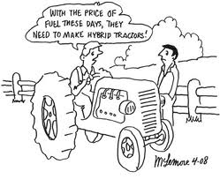
(c) www.gwinnetforum.com

Send your comments and feedback on the e-newsletter at info@hvap.org.np.

